Ex no : 1

Date:

**DDL Commands – CREATE, ALTER, DROP, TRUNCATE**

**AIM:**

To create, alter and drop the table using data definition language

1. **Create table name workers**

|  |  |  |  |
| --- | --- | --- | --- |
| # | Column name | description | Data type |
| 1 | S_no | Serial number | Number (3) |
| 2 | Name | Name of the worker | Varchar (20) |
| 3 | Designation | Position of his/her job | Varchar (10) |
| 4 | Branch | Location of work | Varchar (10) |

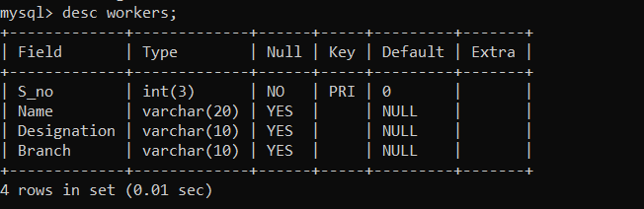

1. **Alter the table by adding salary** 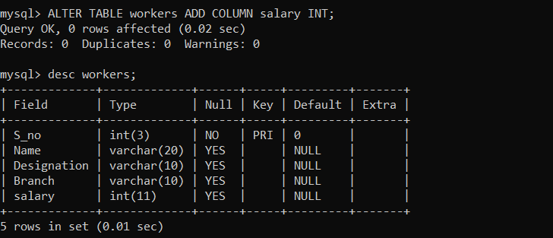
2. **Drop the table workers**

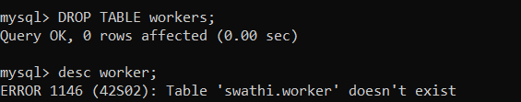

**Result:**

Tables are created, altered and dropped using DDL Command.